* Cosmos DB was made from ground up and scale to many number of transactions in small time.
* <https://docs.microsoft.com/en-us/azure/cosmos-db/introduction>
* Azure Cosmos DB is a globally distributed, multi-model, fully managed database service.
* [https://docs.microsoft.com/en-us/azure/cosmos-db/create-cosmosdb-resources-portal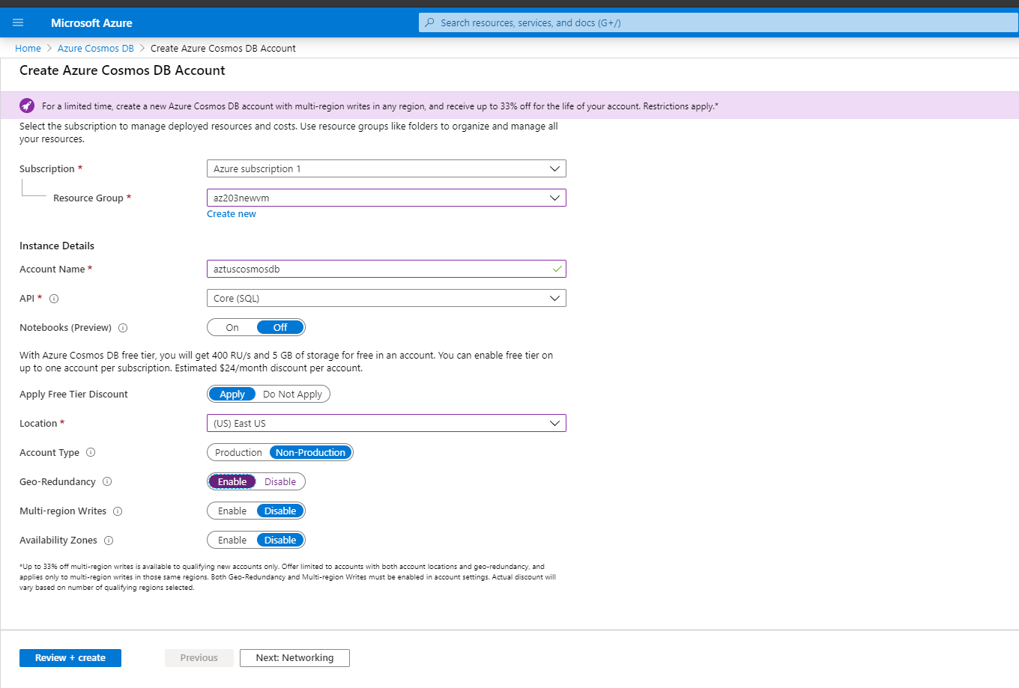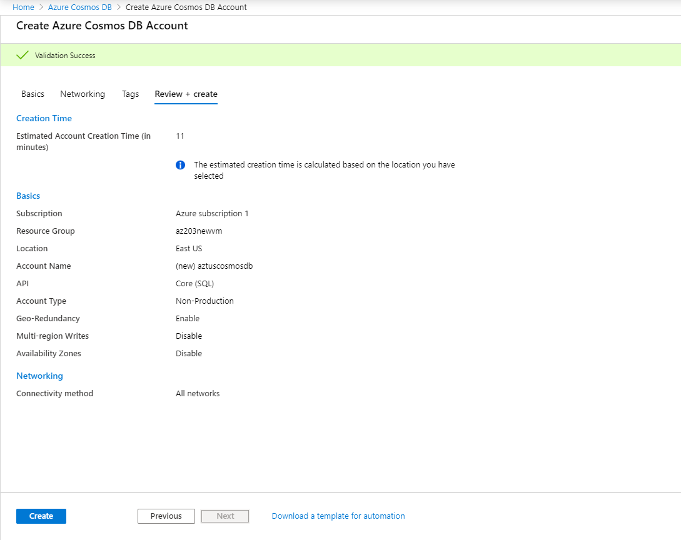](https://docs.microsoft.com/en-us/azure/cosmos-db/create-cosmosdb-resources-portal##)
* Cost for Cosmos Db <https://azure.microsoft.com/en-us/pricing/details/cosmos-db/>